**Assignment_4_extra**

**====================================================================**

**Name:** Ahmed Nour

**Sheet ID:** 16

**Email:** [**ahmedmohamednoour@gmail.com**](mailto:ahmedmohamednoour@gmail.com)

**====================================================================**

**Q1)**

**Verilog code:**

1. **RTL design:**

1. **Testbench code:**

**Simulation Tool**

1. **Do file**

1. **Questasim**

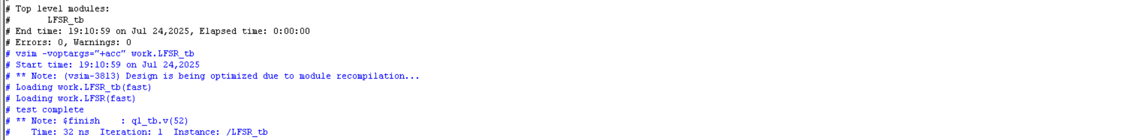



**Q2)**

**Verilog code:**

1. **RTL design:**

**Testbench 1:**

**Simulation Tool for testbench 1:**

1. **Do file**

1. **Questasim**

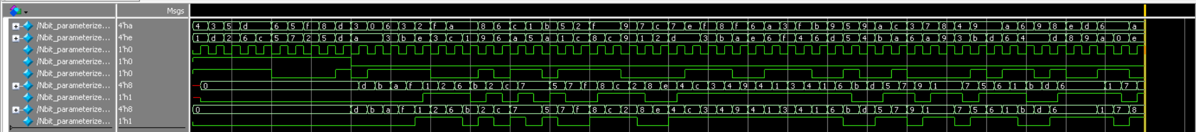

**Testbench 2:**

**Simulation Tool for testbench 2:**

1. **Do file**

1. **Questasim**

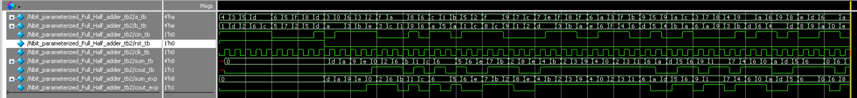

**Testbench 3:**

**Simulation Tool for testbench 3:**

1. **Do file**

1. **Questasim**

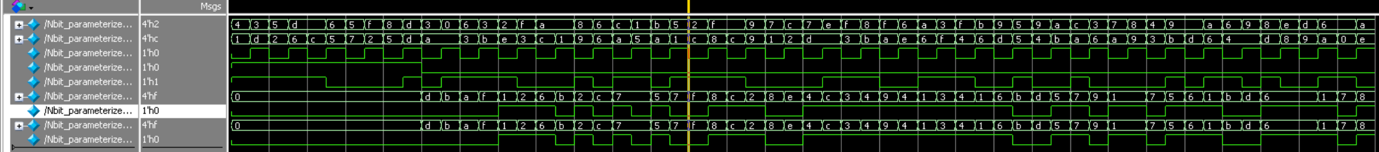

**Testbench 4:**

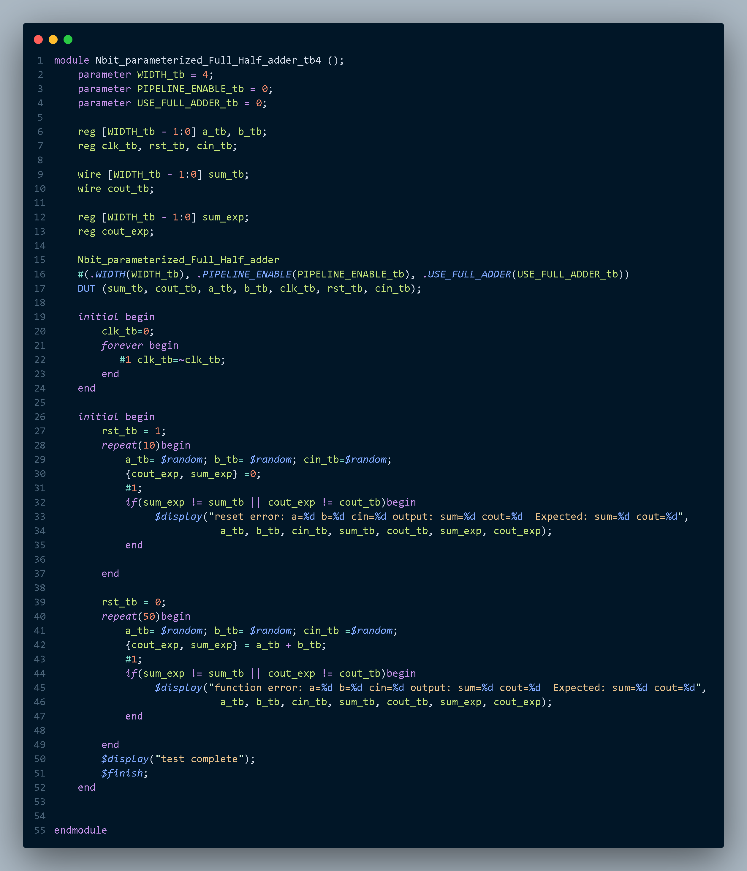

**Simulation Tool for testbench 4:**

1. **Do file**

1. **Questasim**

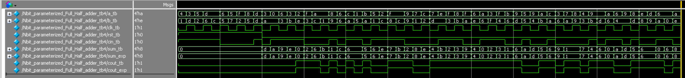

**Q3)**

**Verilog code:**

1. **RTL design:**

1. **Testbench 1:**

**Simulation Tool**

1. **Do file 1**

1. **Questasim 1**



1. **Testbench 2:**

**Simulation Tool**

1. **Do file 2**

1. **Questasim 2**

